In order to start the game, please run “src/gui/ChessGameFrame.java”

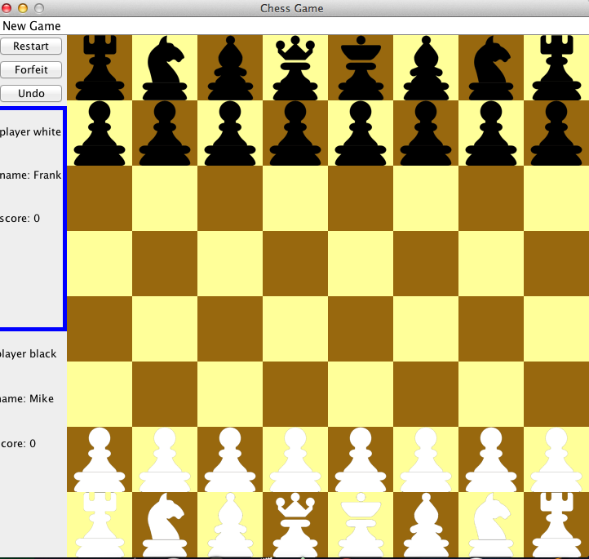

The interface is basically divided into two parts.

On the right part is chessboard. Each piece is properly listed in its initial position. The White pieces are listed at the bottom of the chessboard, and the Black pieces are listed at the top of the chessboard.

On the left part is game panel. On the top part of the game panel, the user can perform some basic operations such as start a new game, forfeit, and undo the previous operations. The part below the control will show the information about players.

I: New Game

1: Start a new game

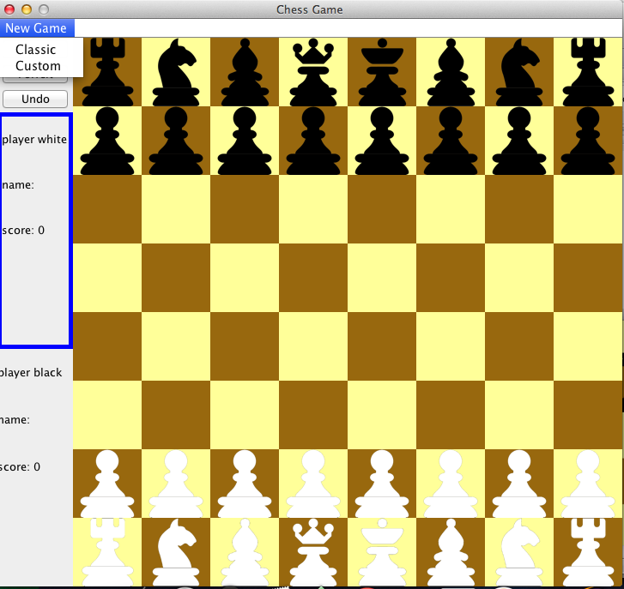

At the menu bar, inside the “New Game” option, users are allowed to create a new game by choosing either “Classic” mode or “Custom” mode. In the custom mode, there will be extra custom pieces on the board initially.

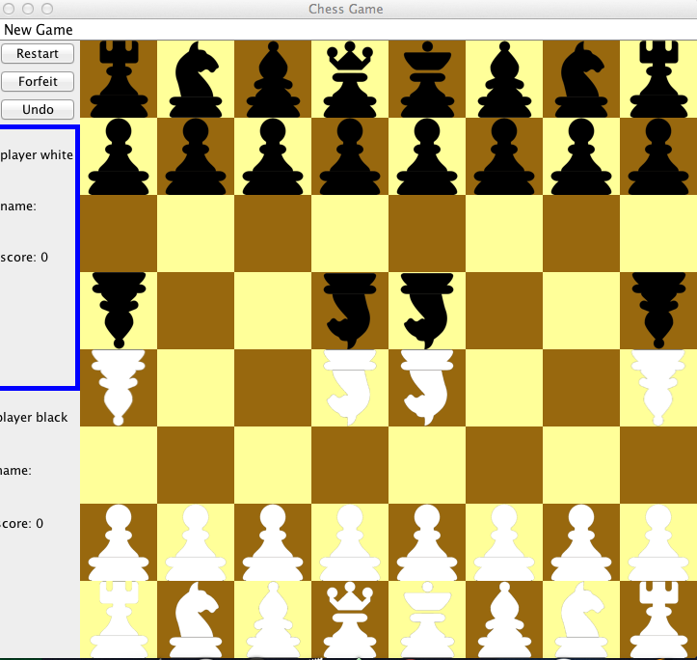

2: Set the players’ name

Every time, users start a new game. They are required to enter the name for each player. After the name is enter the, the information on the left panel will be updated.

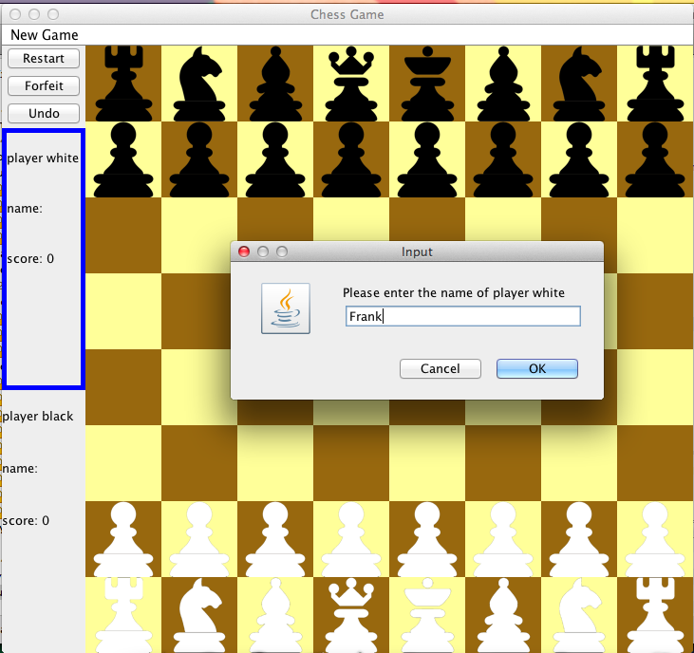

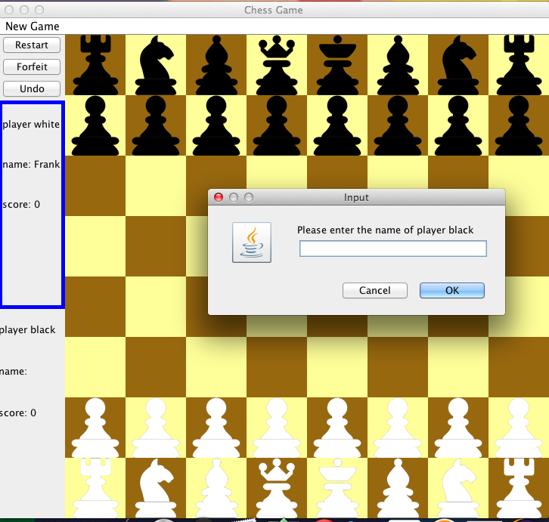  
II: Player Statistics

1: Current player

The current player will be showed in a blue line box.

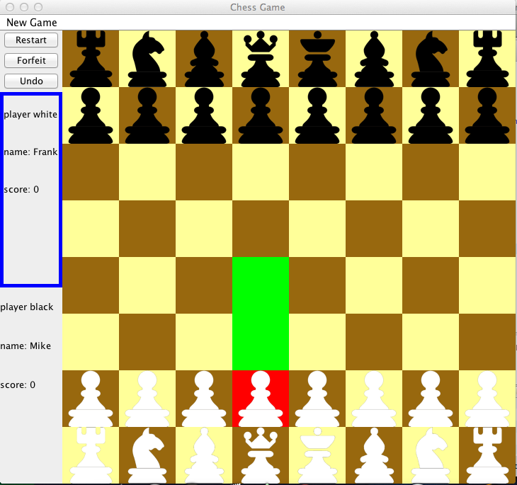

2: Player’s score

The score of player will be updated when the player wins the game

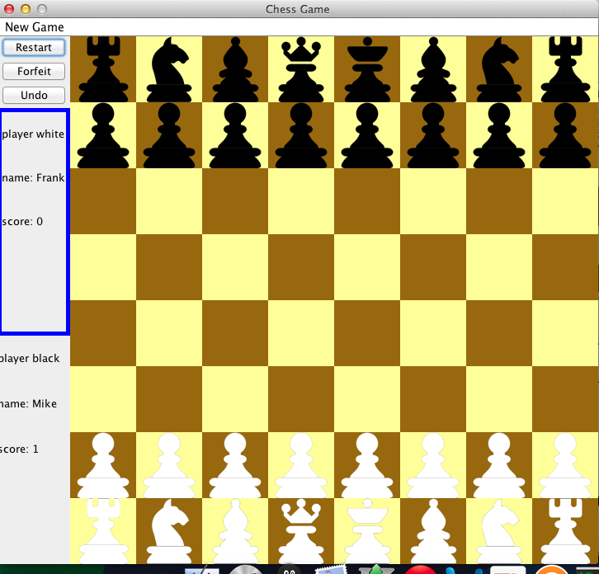

III: Piece Movement

1: Select a piece

A player can selects its own piece by clicking on it. After a piece is selected, it will turn to red and show available locations by representing them in green squares.



2: Move a piece

A player can move its selected piece to available location marked by green color by clicking on it.

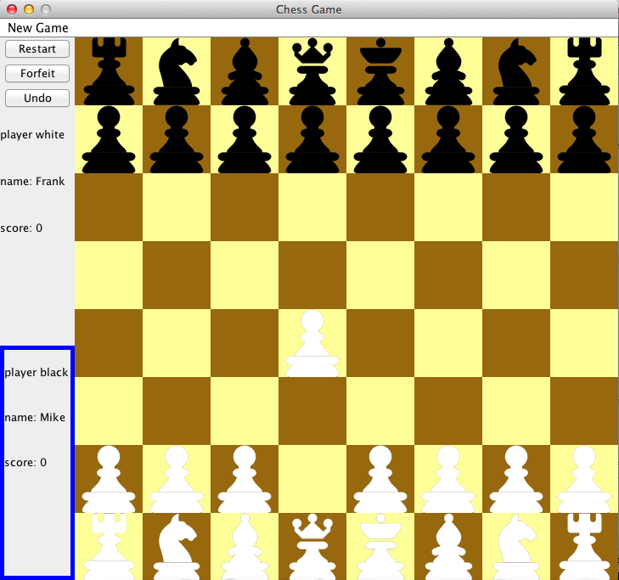

If the player clicks on invalid location, an Error dialog will show up about the “Invalid move”.

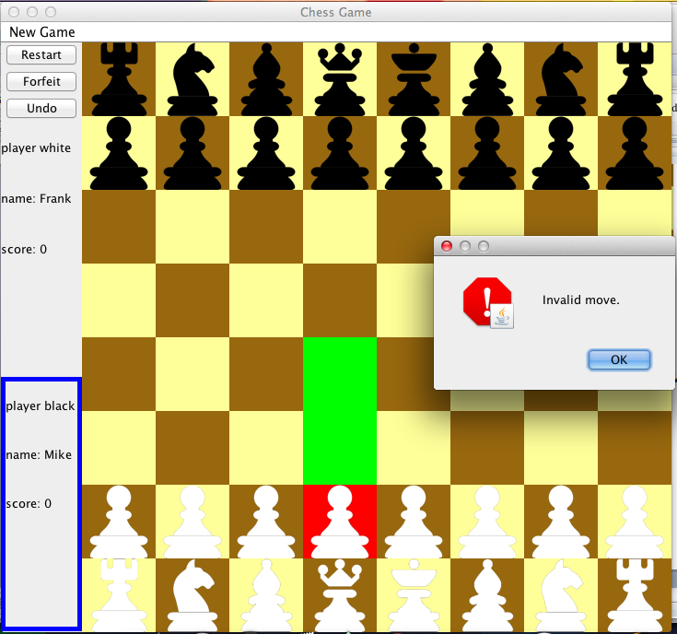

3: Check a king

When a king of one player gets checked, a dialog will inform the player that it has been checked.

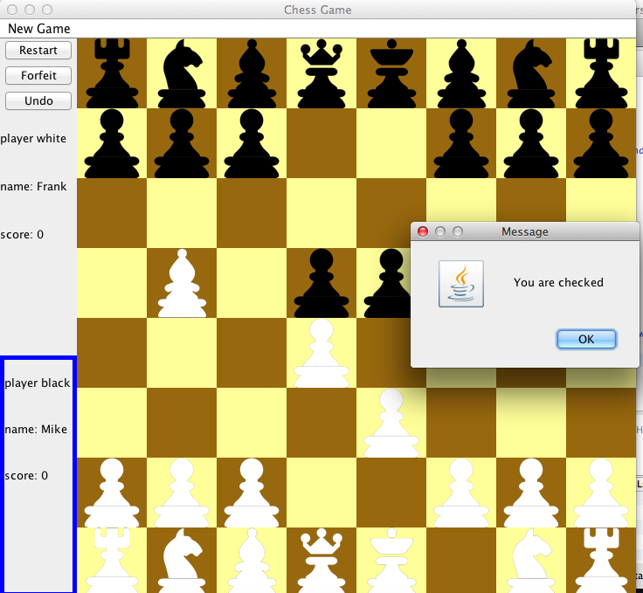

4: Checkmate

A player gets checkmate. A dialog will inform the player that it has checkmate. Its opponent will win the game and increase the score by one. The game will also gets restarted.

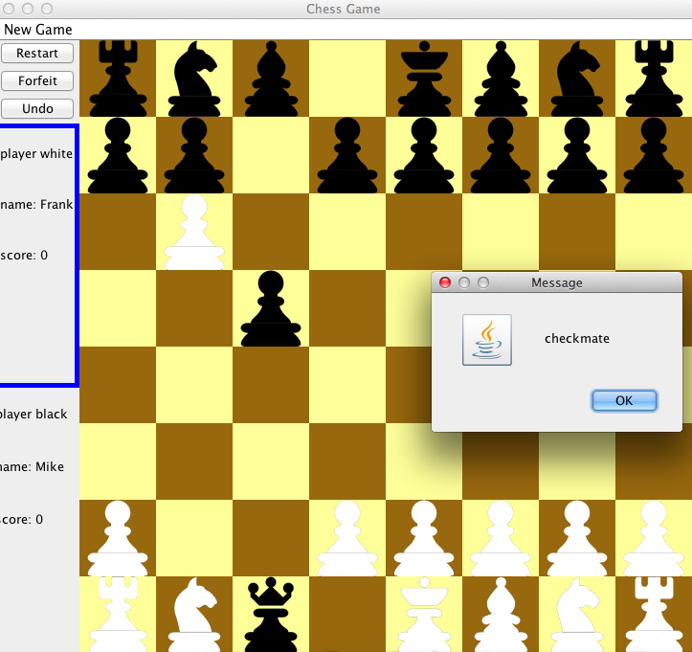



5: Stalemate

A player gets stalemate. A dialog will inform the player that he has stalemate. In that case, the game is drawn and will also restart.

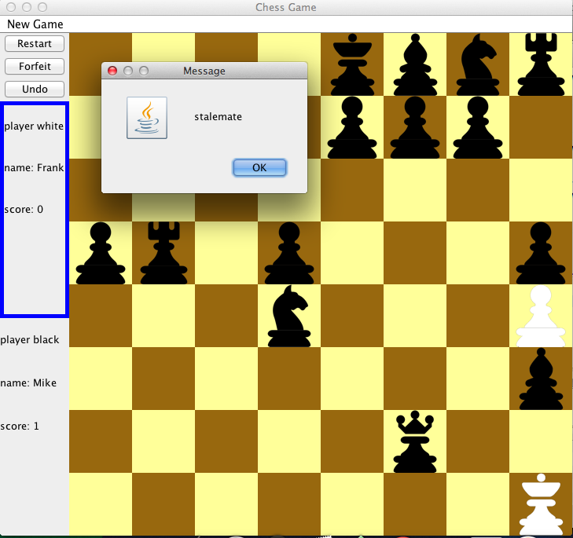

IV: Game Control

1: Restart

A player can initiate a restart request. If its opponent agrees to restart, the current game will restart.

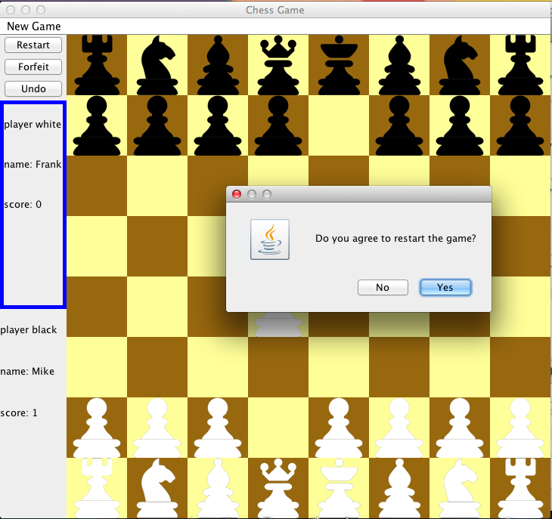

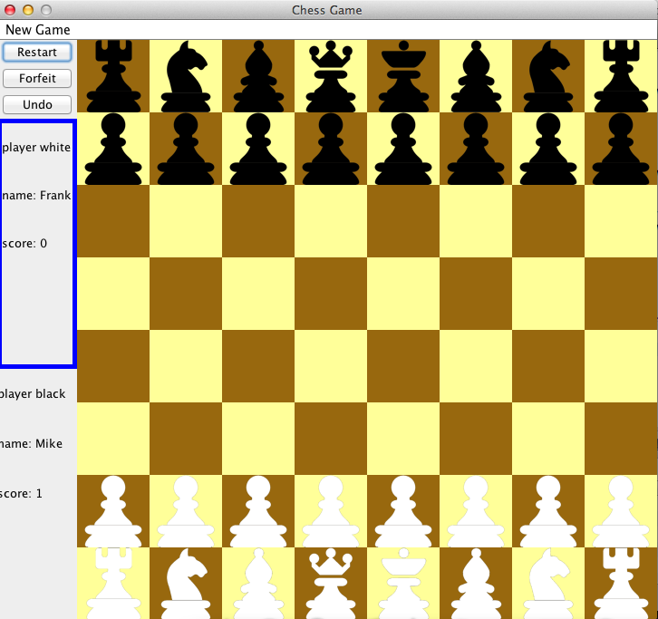

If another player does not agree, the game will not restart.

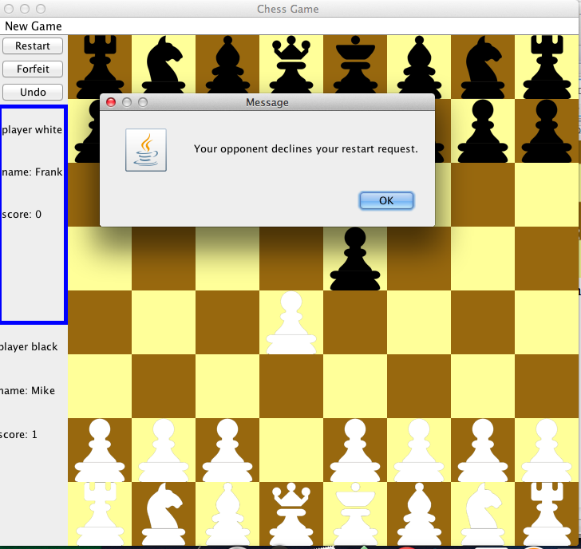

2: Forfeit

If a player forfeits the game, its opponent will win the current game and the game will restart.

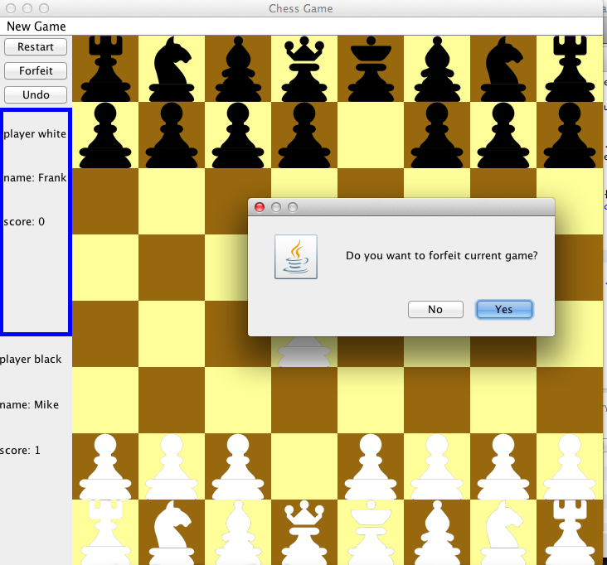

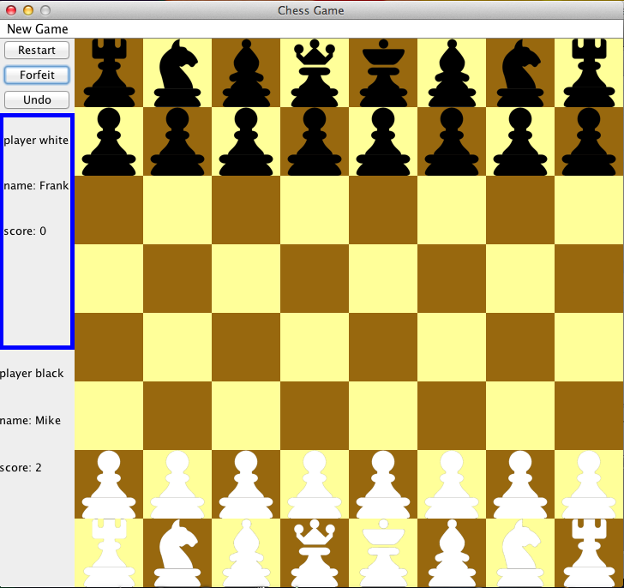

3: Undo

A player can request to undo its previous movement. If its opponent agrees, it will perform undo.

